Chapter 5 Lesson 2 Your Teeth, Eyes, & Ears

Teeth are made up of hard strong tissue that contains ______________.

The surface of your teeth is made up of _____________ the hardest substance in your body.

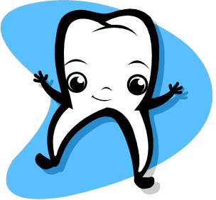

Enamel and a bonelike substance called dentin cover the pulp the part of

the tooth that holds _____________and ______________ ___________.

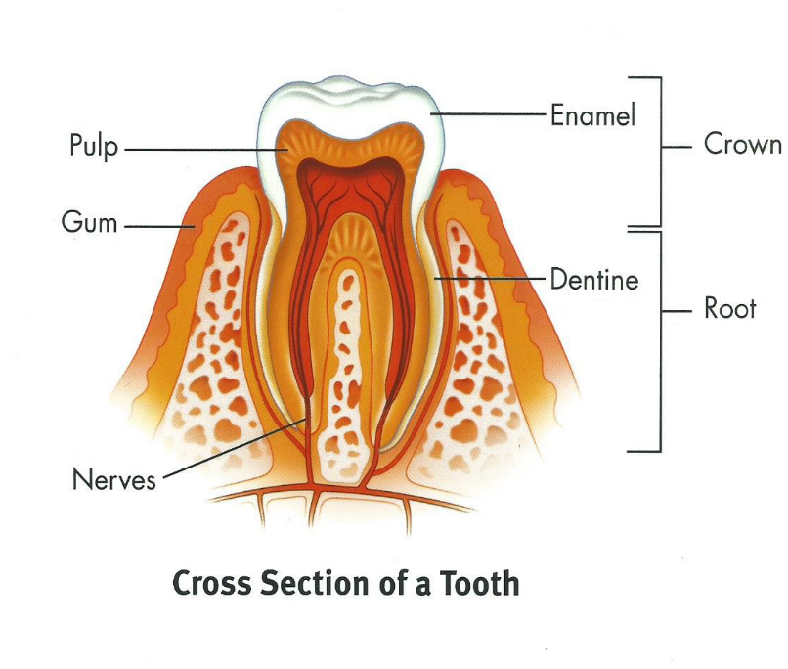

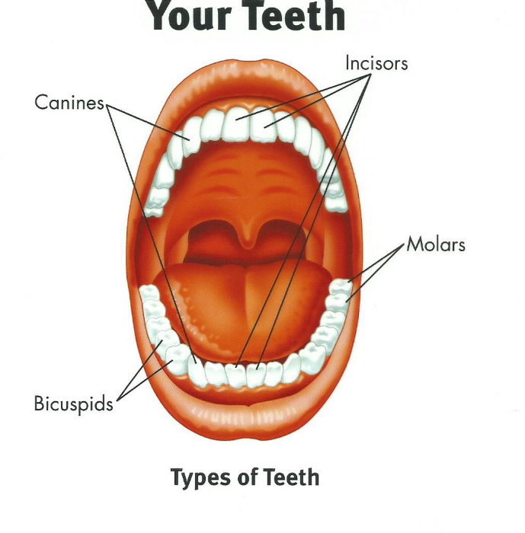

Dental Plaque is a sticky substance on teeth that contains bacteria. Sugar

and plaque makes an acid that can cause a ___________or ________

To help protect your teeth you should do 3 things

- Wear a mouth guard

- Get a check up every __________months

3.

If you don’t take care of your teeth you could get

______________________________

A ________________________ is a dentist who specializes in braces.

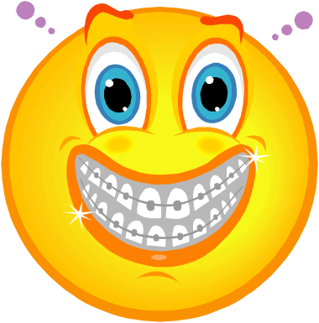

There are three parts to the eye, write the part and its function.

- _____________ a hole in the center of the eye light enters through.

- The ___________focuses the images

3. The _____________sends messages to the brain.

List three ways to keep your eyes healthy
1. Have a doctor check your vision each year.

2.

3.

When you have trouble seeing far, this is called _________________________.

When you have trouble seeing up close, this is called______________________.

List two ways to correct vision problems

- ____________surgery

- _______ ________or contacts

Name the 4 parts of the ear and their function

- _________________ - is the part of your ear you see and helps funnel the sound into the ear drum.

- _________________carries sound to your ear drum

- _________________a thin membrane that vibrates when hit by sound.

- ________________ is shell shaped filled with fluid sends messages to the brain about what you are hearing.

It is important to _____________your ears.

A _______________is a hearing specialist.

Hearing loss is the inability to _________________or _________________certain sounds.

The measure of the loudness of a sound is a __________________.

Repeated exposure to sounds louder than 85 decibels can cause hearing loss.

List 3 ways to protect hearing loss:

- Wear __________ _______________ to reduce sound levels

- Don’t listen to __________music

- Listen to music with _________ ___________.



