**Chapter 12 Alcohol Lesson 1 study guide**

Alcohol is a drug produced by a Chemical Reaction in fruits, vegetables, and grains.

The beverage alcohol is called ethanol alcohol.

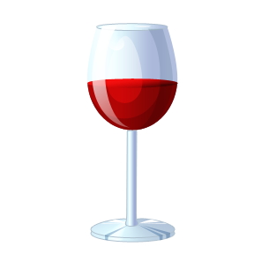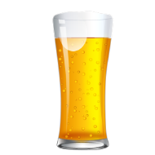

* Is the # 1 drug in America

Alcohol is a depressant. Drugs that slow down the nervous system (functions and reactions) a small amount can affect a person.

* **Alcohol Use and Teens**
* can interfere with long-and short-term growth. It can harm the brain’s ability to **learn** and **remember.**
* Can cause sleep problems
* Teens who drink are more likely to fall behind in school.
* Increases the risk of psychological problems (depression, suicidal thoughts, and violence).
* It is illegal to drink under the age of 21. Teens risk getting in trouble with the law.
* 1/3 of all teen traffic deaths are related to alcohol.

**Why do Some Teens Drink Alcohol?**

* Peer pressure
* Helps forget about problems.
* Makes you look grown up.
* Helps you relax

**Alternatives to Drinking Alcohol**

* Volunteer, get involved in activities, sports or community service.

C:\Users\Robin\AppData\Local\Microsoft\Windows\Temporary Internet Files\Content.IE5\MPMK0EPC\MC900363528[1].wmf C:\Program Files (x86)\Microsoft Office\MEDIA\CAGCAT10\j0199036.wmfC:\Users\Robin\AppData\Local\Microsoft\Windows\Temporary Internet Files\Content.IE5\MPMK0EPC\MC900018739[1].wmf

**Advocacy Groups to Make Good Choices:**

* (SADD)- Students Against Destructive Decisions
* (T.A.T.U.)- Teens Against Tobacco Use