Chapter 12 Lesson 2 Short Term Effects Notes study guide

■Reaction Time is the ability of the body to respond quickly and appropriately to situations. Drinking alcohol slows reaction time.
■Intoxication is when a person’s mental and physical abilities have been impaired by alcohol.

■The Liver breaks down alcohol once it enters the bloodstream.

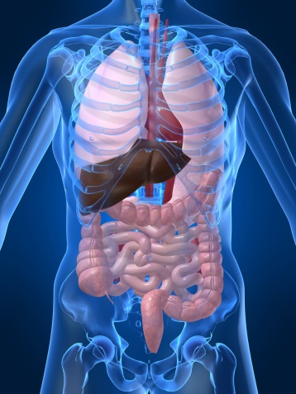

■The measure of the amount of alcohol present in a person’s blood is the
Blood Alcohol Content
BAC of 0.08% is legally intoxicated.
■ A dangerous condition that results when a person drinks excessive amounts of alcohol over a short period of time is Alcohol Poisoning It can kill you!

How alcohol affects the individual

■Gender and body size
■Other drugs
■Food
■General Health
■How fast you drink
■How much you drink

Alcohol content of different drinks

Beer 12oz= wine 5oz=liquor 1.5 oz

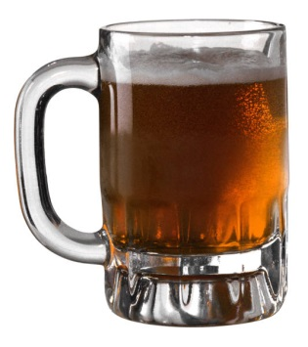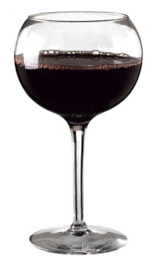l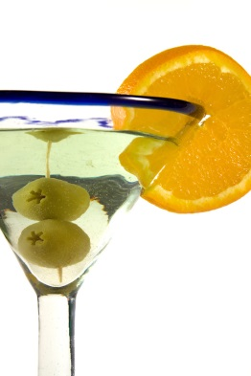
Alcohol & Violence

- Alcohol makes people agressive

- 2/3 of all domestic violence is related to alcohol

- Malnutrition is when the body doesn’t get the nutrients it needs. Alcohol can cause weight gain.

